**Database with Web Interface Assessment - (**[**Assessment**](https://docs.google.com/document/d/1xIfDW1x0ASwTlwVYMzQU7bOjbRB4eCATdSY_UNwI7fA/edit)**)**

**Purpose:**  The purpose of the website - which is created through the implementation of a relational database - is to allow teachers in New Zealand to collaboratively contribute to an online Te Reo dictionary. It will showcase Te Reo to the students but the students are unable to edit it. Through the website, students will be able to learn new words in Te Reo Maori.

# **Database Planning**

**Draft of Data Tables:** (Colour shows relational data tables)

**Table:** year_level

| Year Level ID | Index Key | INT(10) |
| --- | --- | --- |
| Year Level |  | INT(2) |
| Difficulty |  | Varchar (15) |

**Table:** category

| Category ID | Index Key | INT(2) |
| --- | --- | --- |
| Category |  | Varchar (15) |

**Table:** main

| Main ID | Primary Key | INT(10) | Auto Increment |
| --- | --- | --- | --- |
| Maori |  | Varchar (15) |  |
| English |  | Varchar (15) |  |
| Definition |  | Varchar (50) |  |
| Year Level ID | Index Key | INT(10) |  |
| Category ID | Index Key | INT(10) |  |
| Entry Date |  | INT(10) |  |

**Final of Data Tables:**

**Table:** year_level

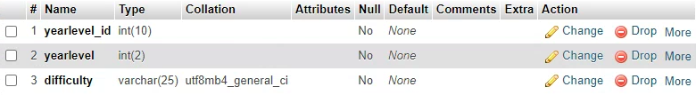

**Table:** category

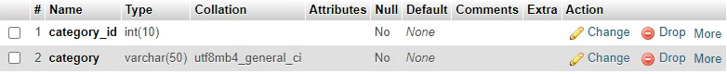

**Table:** main

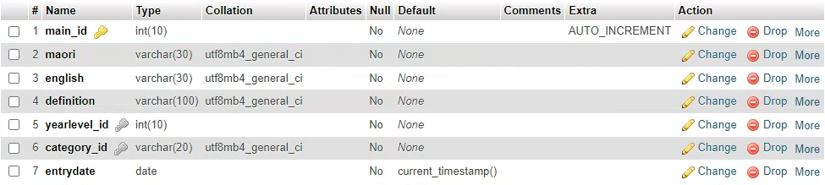

# 

# **Web Interface Planning**

# **Colour Research**

When we look at Maori culture and colours that are often associated with Te Reo Maori, we often consider [red, black and white](https://nzhistory.govt.nz/media/photo/national-maori-flag). This is a possible colour choice with Licorice as the font colour, White as a background colour, Burgundy as the button and subheading background colours. Though this choice represents the Maori culture, it seems rather bold and highly contrasting so it does not appeal as much to the user. The bright white background can be too blinding for the user and though the button and font visibility is great, the background may not be as comfortable. 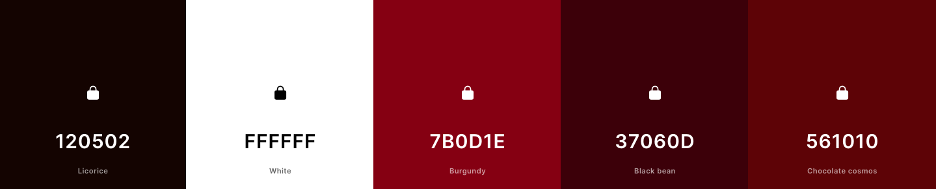

New Zealand is known for its green landscape and lush greenery. The green symbolises the cleanliness and flourishing nature of New Zealand. The idea of flourishing can relate to a Te Reo dictionary as we are “flourishing in our learning”. The green colour scheme inspired by native New Zealand flora and fauna - ferns, korus, kawakawa, kowhai - is an elegant and aesthetically pleasing colour scheme as the greens soothe the user and make the interface more welcoming. For this, the background colour would be Timberwolf as it’s light and so buttons and fonts would stand out better. The font colour for the main headings would be Hunter Green with the main body font being Dark Green - they are both dark so the user can see them better. Fern Green can be used for the buttons and Sage can be used for stylistic elements such as header designs. This is the selected colour scheme.

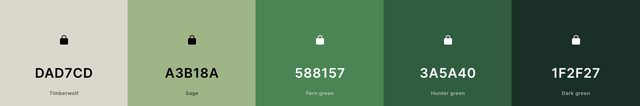

Another nature theme can be focussing more on the tree trunks and forests - or even the New Zealand animals such as the kiwi, karearea and ruru. This colour scheme can influence the design elements of the website as the birds can become icons and stickers for the pages - this draws the attention of the students and more users would enjoy and appreciate the website. However, the colour scheme is too dark and similar, so the subheadings and fonts may blend in together and may look bland. 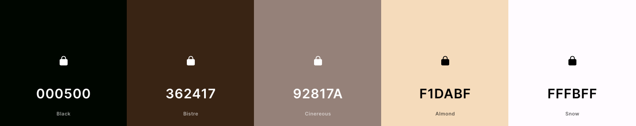

# **Font Research**

**Heading Fonts:**

| **Font Name and Idea:** | **Example:** |
| --- | --- |
| [Playfair Display](https://fonts.google.com/specimen/Playfair+Display?category=Serif,Sans+Serif) (Bold 700) |  |
| [Nunito Sans](https://fonts.google.com/specimen/Nunito+Sans?preview.size=18&category=Serif,Sans+Serif) (Bold 700) |  |
| [Ysabeau Office](https://fonts.google.com/specimen/Ysabeau+Office?preview.size=18&category=Serif,Sans+Serif) (Bold 700) |  |

**Body Fonts:**

| **Font Name and Idea:** | **Example:** |
| --- | --- |
| [Roboto](https://fonts.google.com/specimen/Roboto?category=Serif,Sans+Serif) (Regular 400) |  |
| [Open Sans](https://fonts.google.com/specimen/Open+Sans?category=Serif,Sans+Serif) (Regular 400) |  |
| [PT Sans](https://fonts.google.com/specimen/PT+Sans?category=Serif,Sans+Serif) (Regular 400) |  |

# **Banner Designing**

Inspiration for the banner began from the colour scheme chosen - the forest tones could be complemented by yellows to create a kowhai motif throughout the interface. The kowhai motif also inspired the website's name.

**Final Banner:**

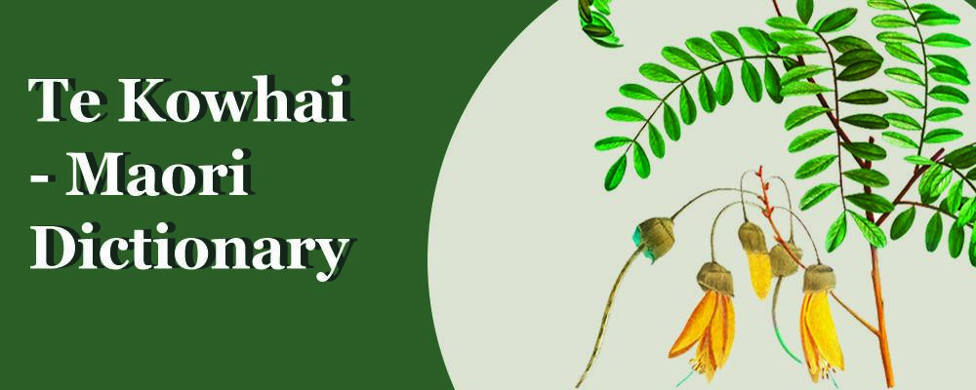

Image for Banner Reference: <https://www.flickr.com/photos/153584064@N07/33349807318>

# **Website Planning**

| **Login Page:** | **Home Page:** | **Profile Page:** |
| --- | --- | --- |
| **Wordlist Page:** | **Editlist Page:** |  |

# **Development of Database**

**Trial 1: Creation of dictionarydb and Data Tables**

The image above shows the MySQL database named ‘*dictionarydb*’. This is where the information for the words in the Te Kowhai dictionary is stored. This database will store the main table which is what the tables in the website display, the year level table and the category table. The main table stores the main_ id,maori name, english name, definition, year level, category and entry date. The yearlevel table holds the yearlevel_id, year level and difficulty while the category table holds the category_id and the category.

The multiple tables are relational tables meaning that are all linked. The year-level table is linked to the yearlevel_id stored in the main table and the category table is linked to the category_id in the main table. This allows for better organization and storage of data.

| **Creation of dictionarydb** | **Creation of main table** |
| --- | --- |
|  |  |
| **Creation of yearlevel table** | **Creation of category table** |
|  |  |

**Trial 2: Importing Data**

Data containing all the information regarding the words that were to be stored in the dictionary were imported into the tables within the database.

| **Importing in yearlevel table** | **Importing in category table** |
| --- | --- |
|  |  |

An error did appear when importing data into the main table. It kept only adding one line of data (only one word) and it did not add any of the other words to the table:

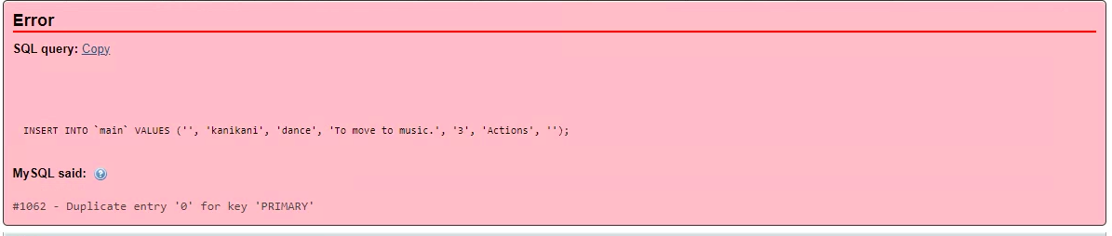

This error was caused because the column for main_id was empty and so all the words had the same main_id which is why the database was unable to accept it. This issue was solved by auto-incrementing the main_id in the main table to ensure that each word had a unique ID that it was assigned. After changing this, all the words were successfully imported. All this data was displayed on the editlist page and the wordlist page.



**Trial 3: Re-doing my Year Level Table**

| **Error** | **Outcome** |
| --- | --- |
|  |  |

A small error appeared while I was doing my edit list page’s dropdown. For some reason, the yearlevel table had extra rows filled with zeros and this caused a large gap in my dropdown for year-level. It did not affect the functionality of it, it just looked unprofessional. I tried to delete all the rows in the table and re-import the data but the zeros kept coming in. So to solve this problem, I created a new year-level table called year_level and imported the data per usual - this gave the final outcome which worked perfectly.

# **Development of Website**

**Trial 1: Login Page** (Resource: Secure Login System with PHP and MySQL ([LINK](https://codeshack.io/secure-login-system-php-mysql/)))

| **Code for Login Page** | **Style Sheet** | **Outcome of Login Page** |
| --- | --- | --- |
|  |  |  |

The code above shows the main code for the Login page of Te Kowhai Dictionary. This is where the user will log in to access the words in the dictionary. The Login page contains a username and password to allow the user to be able to store their data knowing that it is safe and well organised. The stylesheet was used to design the Login page so that it can use its specific colour palette. The background is soothing and calming for the user and the dark greens of the main icons allow it to be eye-catching and ‘easy-to-navigate-through’. When the user clicks ‘Login’, it will lead to the Home Page.

This is accomplished by the *authenticate.php* file (below) which allows for connecting the two pages together and checks the username and password. If the username and/or password is incorrect, the interface will tell you that you have an incorrect username or password. Otherwise, it will lead to the Home Page.

| **Code for authenticate.php** | **If incorrect username or password:** |
| --- | --- |
|  |  |

**Trial 2: Home Page** (Resource: Secure Login System with PHP and MySQL ([LINK](https://codeshack.io/secure-login-system-php-mysql/)))

| **Code for Home Page** | **Style Sheet** | **Outcome of Home Page** |
| --- | --- | --- |
|  |  |  |

The code above shows the code for the Home page of Te Kowhai Dictionary. This is where the user will see the list of the words and be able to access the rest of the dictionary. They will also be able to navigate through to their profile and log out when they have finished. The Home page contains the option to view a user’s profile and to log out. The stylesheet was used to design the Home page so that it can use its specific colour palette. The background is soothing and calming for the user and the dark greens of the main banner are for an aesthetically pleasing look. The white of the font stands out against the green so users are able to view it easier.

**Trial 3: Profile Page and Logout** (Resource: Secure Login System with PHP and MySQL ([LINK](https://codeshack.io/secure-login-system-php-mysql/)))

| **Code for Profile Page** | **Outcome of Profile Page** |
| --- | --- |
|  |  |

The code above shows the code for the Profile Page - this where the user’s username, password and email are displayed. This allows the user to know what the information that they have added to the website is. It is a simple page and has similar styling to the home page.

The code below shows the code for the Logout page located on the navigation bar. Once this is clicked, the website will redirect the user to the login page if they wish to re-enter again.

| **Code for Logout** | **Outcome of Logout** |
| --- | --- |
|  |  |

**Trial 4: Wordlist Page**

| **Code for Wordlist Page** | **Error** | **Solution to Error** |
| --- | --- | --- |
|  |  | How it was solved:    Outcome: |

The code above shows the beginnings of the Wordlist Page. This is the page where users would be able to see the entire dictionary and they will be able to search for words and be able to use pagination to navigate through the large list. After creating the the wordlist.php, the first error prevented the user from seeing the data from the data tables - the headings were shown just not the data. This error was solved by adding *$result = $conn -> query($sql)*. The issue was that the query was not defined correctly resulting in the data not being displayed correctly.

To make the page look more professional and to organise it, the CSS code below was used to make this outcome. This is the earlier look of the wordlist page.

| **CSS Code** | **Outcome** |
| --- | --- |
|  |  |

After updating the wordlist to match the dictionary and store the correct words, the code for the wordlist.php changed slightly to fit the aesthetic of the website and to ensure that the website had consistency.

| **Altering the Wordlist.php** | **Outcome** |
| --- | --- |
|  |  |

**Trial 5: Editlist Page**

| **Creation of Editlist.php** | **Creation of Editlistprocesses.php** |
| --- | --- |
|  |  |

The code, above, shows the creation of the editlist.php which is the page where users are able to edit, delete and update words in the Te Kowhai dictionary. The editlist was made using the resource PHP CRUD Tutorial ([LINK](https://youtu.be/3xRMUDC74Cw?si=83DkgN2Ta9siVFbo)). The editlistproccess.php is where all the functionalities of the edit list are stored. This is where the interface gets its code when the user wants to delete/edit/update/save a word to the table. When a code is deleted/edited/updated, it automatically changes it in the main table so that wherever the data is displayed, the updated version is displayed. There were quite a few errors for this page:

1. When displayed, the action column which stores the buttons edit and delete was not functioning correctly and was not showing the buttons. This error was because, for the button’s code, instead of main_id, I accidentally kept it id which caused the editlistprocess.php to view it as an unknown variable. Once changed to main_id, the error was solved.

| **Error** | **How Error was solved** | **Outcome** |
| --- | --- | --- |
|  |  |  |

1. Another error I came across was with my textboxes (which was where the user would insert their new word) - they kept displaying an error (as shown below). This was a much smaller error caused by mistyping the placeholder. This was solved by ensuring that all the code was in the right order and that the placeholders had the correct input - also ensuring that each text box had the correct ID.

| **Error** | **How it was solved** |
| --- | --- |
|  |  |

1. When trying to add a new word to the table, an error appeared and this was caused because there was a primary key on the category_id within the main table rather than the index key that allowed for the relational data table. Having a primary key prevented users from adding to the table as that category row became locked. However, this problem was solved by removing the primary key -I used a code that allowed me to easily drop primary keys (Reference to code: [How to remove a primary key](https://learnsql.com/cookbook/how-to-remove-a-primary-key-in-sql/#:~:text=To%20drop%20a%20primary%20key%20from%20a%20table%2C%20use%20an,primary%20key%20column(s).))- and ensuring that it was just an index key. The index was added by re-adding the foreign constraints back the create the relations between the tables.

| **Error** | **How Error was solved** | **Outcome** |
| --- | --- | --- |
|  |  |  |

1. When trying the delete button, it would redirect the user back to another page which was not related to this interface - it redirect it to an old PHP CRUD page (a prototype for the Editlist Page). This was simply caused by incorrect linking and was solved by ensuring that the delete button was linked to the correct database and to the correct process.php. The same error also happened to the edit button was also solved the same way.

| **Error** | **How Error was solved** | **Outcome** |
| --- | --- | --- |
|  |  |  |

1. When trying to edit a word and update it, another error appeared and this was because of an unknown column created by accident. Similar to the mistake prior, in some areas of the code, I forgot to change id to main_id which is why the code has an unknown variable. Once this was changed (as shown below), the code began to function correctly.

| **Error** | **How Error was solved** | **Outcome** |
| --- | --- | --- |
|  |  |  |

**Trial 6: Dropdown in Editlist**

| **Initial Code** | **Error** |
| --- | --- |
|  |  |

The dropdown list was added amongst the text boxes in the edlitlist.php to make it easier for the user to select a category and a year level - it allowed them to see the range of categories and year levels the dictionary accommodated for.

When first adding the dropdown code, the first error was that everything below the category dropdown (this was the table storing the words and actions, the footer, and the entry date text box) all disappeared and the category dropdown only showed “*Select Category*”. This error was more complicated and the reason was that the mysql connection code was not working correctly - this meant that the table did not connect to the category table in dictionarydb. This was solved by replacing the old MySQL code (as shown below) with a new MySQL code that established a connection to the table. The disappearing table was caused by incorrect class and division - originally the class was “*column is-10*” which didn’t exist and so it was changed to match the other textboxes (class = “*form-group”).*

| **New Code** | **Outcome** |
| --- | --- |
|  |  |

Another issue was that instead of showing the category name when added to the table, it kept showing the category_id - this would confuse users as it doesn’t categorise the words into the name of the category but rather the number of the category. This issue was caused by linking the incorrect row that codes how the data looks when published (I connected it to the category_id rather than the category). When the *echo $row[‘category_id’]* was changed to echo *$row[‘category’]*, then the issue was resolved.

| **Error** | **How Error was solved** | **Outcome** |
| --- | --- | --- |
|  |  |  |

The same dropdown was added to the year level:

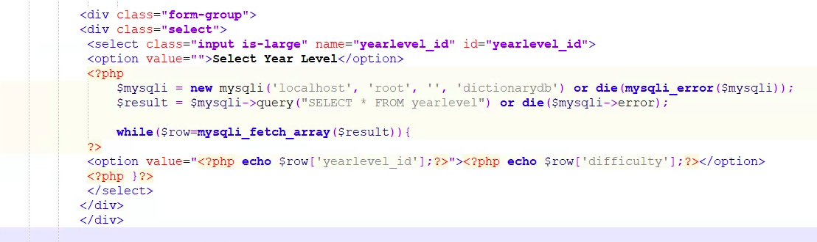

**Trial 7: Search Bar**

| **First attempt at Search** | **Outcome** |
| --- | --- |
|  |  |

The first attempt at the search bar was very unsuccessful. Firstly, I tried to combine the search bar with the pagination code - which did not work as they had a bug that prevented them from working together in the same code (*explained further in Trial 10*). The code above also did not work and the search bar was only there for display as the search button would not work nor would the search bar.

The second attempt was done using a filter search which turned out successful (Reference to code: [w3schools Filter Search](https://www.w3schools.com/howto/howto_js_filter_table.asp)). The reason my search bar was not working was because of a lack of Javascript at the bottom but once that was added and a shorter and more efficient search code was added the code began functioning. But an error occurred, whenever I tried to search for something, all the words would disappear (as shown below).

| **Final Code for Search** | **Outcome** | **Error** |
| --- | --- | --- |
|  |  |  |

This error was caused because the search bar was reading the wrong column in the table. After experimenting, I found that it read the main_id column rather than the Maori words. So when numbers were entered into the search, it worked normally. So the problem was fixed by removing main_id from all of my code - it was still there but it wouldn’t be displayed in the table. By putting the Maori column first, it will now search by the Maori word. The search bar was added to the wordlist page (initially) so users could search for words more easily. The search bar only recognises - only searches - the Maori words. This is because as it is a Te Reo Maori Dictionary, it seems fitting that users will come to translate Maori words or test their knowledge of the language.

| **How it was Solved** | **Final Outcome** |
| --- | --- |
|  |  |

**Trial 8: Pagination**

| **First attempt at Pagination** | **Outcome** |
| --- | --- |
|  |  |

Similarly to the Search bar, the Pagination took many attempts. The Pagination is for the wordlist.php as it allows users to easily navigate through the large list of words by breaking the large table into separate pages. The first attempt at the code was also unsuccessful - the buttons would not click and the pagination simply did not work.

After some more trial and error, I used new code (Reference to code: [Simple Pagination](https://www.allphptricks.com/create-simple-pagination-using-php-and-mysqli/)) which somewhat worked but an error came up that ruined the table as shown below.

| **Code for Pagination** | **Error** |
| --- | --- |
|  |  |

This error was caused by two pieces of code - both coding for the table. This resulted in the codes getting mixed up and not functioning correctly. So, this error was solved by removing the table code I had earlier underneath the table‘s header names (which was mostly PHP code) and adding the correct PHP within the pagination code - this made sure that the pagination was actually linked with the table. This caused the pagination to work correctly and after some CSS styling, the final outcome of the pagination is shown below.

| **Final Code for Pagination** | **Outcome** | **Styling with CSS** |
| --- | --- | --- |
|  |  |  |

**Trial 9: Banner**

| **Error with Banner** | **How it was solved** | **Final Outcome** |
| --- | --- | --- |
|  |  |  |

The banner was added to the top of the home page above the navigation bar but when added it removed the styling from the rest of the home page. This was because of the incorrect placement of the CSS code for the banner. I relocated it to the bottom and the code began to function as normal.

**Trial 10: Extra - The Pagination and Search ‘Bug’ and ORDER BY**

| **Pagination and Search ‘Bug’:** | **ORDER BY:** |
| --- | --- |
| A bug was found in the wordlist page during the interaction between the search bar and the pagination. The issue was that the search bar would only search words displayed on that page rather than all the words from the entire dictionary. This would be an inconvenience to the users so to solve this problem, the search bar was placed in the Home page while the pagination remained in the Wordlist page. This prevented their interaction and so both the codes could function normally. | In the Editlist Page, the order of the table was oldest words to newest words which would be inconvenient for the user as they would have to scroll to the bottom of the table to view the latest addition. To save time, I added the ORDER BY main_id DESC to make sure that the code was ordered by the most recent main_id (which is the newest word). (Reference to code: [Stackoverflow](https://stackoverflow.com/questions/36242528/sort-data-by-newest-to-oldest-php)) |
| **Search Bar added to Home Page:** | **Code:** |
| **Pagination kept in Wordlist Page:** | **Final Outcome:** |

# **Final Testing**

Link to Final Testing Video: [Alpa Sahai - Final Testing Video for Database and Website](https://drive.google.com/drive/folders/1h-NeL_UVYhbul0xyIwg-4v5w9gJxTKsd)

**Testing Navigation Bar:**

Link to Navigation Bar Testing Video: [Alpa Sahai - Navigation Bar Testing Video](https://drive.google.com/drive/folders/1h-NeL_UVYhbul0xyIwg-4v5w9gJxTKsd)

This was testing the navigation bar in all of my pages to ensure that they all lead to the correct page and that they all functioned correctly.

Navigation Bar:



| **Starting Page** | **What it leads to** |
| --- | --- |
| Login Page: | When Login is clicked: |
| Home Page: | When Wordlist is clicked:  When Editlist is clicked:When Profile is clicked:  When Logout is clicked: |
| Wordlist Page: | When Home is clicked:    When Editlist is clicked:When Profile is clicked:  When Logout is clicked: |
| Editlist Page: | When Home is clicked:    When Wordlist is clicked:When Profile is clicked:  When Logout is clicked: |
| Profile Page: | When Home is clicked:    When Wordlist is clicked:    When Editlist is clicked:  When Logout is clicked: |
| Logout Page: | When Logout is clicked: |

**Testing Login Page:**

Link to Login Page Testing Video: [Alpa Sahai - Login Page Testing Video](https://drive.google.com/drive/folders/1h-NeL_UVYhbul0xyIwg-4v5w9gJxTKsd)

This is to ensure that the user is able to enter the database with the correct information - correct username and password.

| **Testing Login** | **Outcome** | **Explanation** |
| --- | --- | --- |
| If both fields are filled with correct information | Leads to: | If both fields are filled with correct information, then the interface allows the user into the dictionary and takes them to the home page as expected. |
| If both fields are filled with incorrect information |  | If both fields are filled with incorrect information, the *authenticate.php* will take the users to a page that informs them that their username and password are incorrect. The user will understand and go back to the Login Page to try again. |
| If one of the fields is filled with incorrect information |  | If one of the fields are filled with incorrect information, the *authenticate.php* will take the users to a page that informs them that their username and password are incorrect. The user will understand and go back to the Login Page to try again |
| If only the username field is filled |  | If only the username field is filled and the user presses login, a message appears that informs the user that this field is empty. Only when they fill both fields with the correct information will they be allowed into the dictionary. |
| If only the password field is filled |  | If only the password field is filled and the user presses login, a message appears that informs the user that this field is empty. Only when they fill both fields with the correct information will they be allowed into the dictionary. |

**Testing Pagination:**

Link to Pagination Testing Video: [Alpa Sahai - Pagination Testing Video](https://drive.google.com/drive/folders/1h-NeL_UVYhbul0xyIwg-4v5w9gJxTKsd)

| **Testing Pagination** | **Outcome** | **Explanation** |
| --- | --- | --- |
| Pages 1-5 |  | Here I am testing my pagination to check if all 15 rows per page appear in the correct order (in order of main_id). |
| Pages 6-11 |  | Again, I am testing my pagination to check if all 15 rows per page appear in the correct order (in order of main_id). |
| Pages 11-16 |  | Again, I am testing my pagination to check if all 15 rows per page appear in the correct order (in order of main_id). |
| Pages 16-21 |  | Again, I am testing my pagination to check if all 15 rows per page appear in the correct order (in order of main_id). |

**Testing Search Bar:**

Link to Search Bar Testing Video: [Alpa Sahai - Search Bar Testing Video](https://drive.google.com/drive/folders/1h-NeL_UVYhbul0xyIwg-4v5w9gJxTKsd)

| **Testing Search Bar** | **Outcome** | **Explanation** |
| --- | --- | --- |
| Search Maori Words |  | The search bar is only able to recognise Maori words as this is a Maori dictionary therefore it is able to search up any of the Maori stored in the table. |
| Search English Words |  | The search bar is unable to recognise English words so does not search according to it. It does search by its Maori counterpart. |
| Search Numbers |  | The search bar is unable to recognise numbers and it only recognises letters that are present in the Maori words. |
| Search Characters |  | The search bar is unable to recognise characters and it only recognises letters that are present in the Maori words. |

**Testing Editlist Page Page:**

Link to Editlist Page Testing Video: [Alpa Sahai - Editlist Testing](https://drive.google.com/drive/folders/1cb41-4623TTGCaAC-BbMscBaVelSqtrX)

| **Testing Search Bar** | **Outcome** | **Explanation + Solutions** |
| --- | --- | --- |
| Save Button |  | When adding a new word to the table (after all the input has been filled), the save button is pressed. This allows for the new word to be entered in the main table of the dictionarydb and thus allowing it to be displayed correctly on all tables on the interface. |
| Deleting Button |  | When deleting a word from the table, the delete button is pressed. This allows for the word to be removed from the main table of the dictionarydb and thus allows it to be removed from all tables on the interface. |
| Editing Button |  | When wanting to edit a word, the edit button is pressed. This allows for the word’s information to be re-entered in the textboxes and dropboxes for easy editing. |
| Updating Button |  | When updating a word after editing, the update button is pressed. This allows for the edited word to be altered in the main table of the dictionarydb and thus allowing it to be displayed correctly on all tables on the interface. |
| If the drop box is empty | Before changing code:  How the code was changed:    After changing the code: | While testing, I realised that when the dropdox was empty, the interface still accepted it like a new word. This is an error.  So to fix this so that every time there will be something for the year level and category, I have made it so that there is a default category and year level (default category is Action and default year level is Basic (1)). This will ensure that these fields are always filled. This error was fixed by removing the option line in the code which removed the placeholder “Select Category” and “Select Year Level”. |

# **Relevant Implications**

**Purpose**

As we know, the purpose of the website is to allow teachers in New Zealand to collaboratively contribute to an online Te Reo dictionary. It will showcase Te Reo to the students but the students are unable to edit it. Through the website, students will be able to learn new words in Te Reo Maori. I think that the Te Kowhai dictionary has met its purpose as the dictionary is able to add, delete and edit words into a table allowing users (in this case, teachers) to contribute to the dictionary. The dictionary also displays the table of Maori words in an organised fashion (pagination) and students are able to search through the list to find the Te Reo words that they need. Teachers are also able to view their profiles and log in and out of the dictionary as they please. To make this beneficial for teachers, words can be divided into categories and year levels which in turn help students identify where they are at in their learning. The large range of year levels and categories also provide more learning opportunities for the students allowing them to fully engage with the website. Therefore, Te Kowhai Dictionary is a useful and fun tool that holds many advantages when helping students learn Te Reo Maori or build on their skills. It is beneficial for young learners who wish to expand their knowledge, delve deeper into the Maori language and learn more about the culture of the people.

**End-user Considerations**

The Te Kowhai Dictionary is primarily aimed towards young students and teachers who want to learn or further learn Te Reo Maori. Keeping this in mind, during the design stages of the website, this was kept in mind to ensure the website’s components and functionality would be understood by a wide range of users. To achieve this, simplistic but stylish components (banners, buttons, fonts) were used as they made the website visually appealing but also made it straightforward and easy to navigate through. By removing excess design elements that could potentially confuse users who have never used an interface similar to this, the interaction between users and the interface was kept efficient and effective. This allowed for the maximum satisfaction of the users. To accommodate users who are not a fan of a ‘loud’ colour scheme, the selected colour scheme has duller or paste colours to make the website more appealing and inviting. To accommodate users who have visual impairments, the font size was kept large and headers were stand out - dark text against light backgrounds or light text against dark backgrounds. This made it easy to read and easier to navigate and identify pages. The buttons and messages displayed when adding/deleting/editing words into the dictionary were kept stand out and obvious so that the user understood what was going on and what each button meant. These factors are highly significant as they allow users to use the interface to its fullest ability and get the most out of their learning - whether that be for students or teachers.

**Cultural**

In regards to the cultural implications, this interface has gone to lengths to ensure that this dictionary is appropriate and respectful to Maori culture. It is crucial when representing other cultures to represent them with dignity and with correct information as we do not want to undermine the traditions and the language. For this reason, a lot of research has been done when incorporating Maori culture into the website. The name Te Kowhai Dictionary was chosen as it represents the nature and growth found in the country and kowhai are used as a symbol of personal growth and renewed sense of adventure (Reference: [Pukaha](https://pukaha.org.nz/5-native-plants-used-in-maori-medicine/#:~:text=Kowhai%20is%20said%20to%20symbolise,%2C%20shingles%2C%20dandruff%20and%20gonorrhoea.)). This relates to the dictionary as learning a new language or continuing your journey in one is about growth and learning. It relates to the sense of adventure as learning is an adventure that has challenges and new experiences; so Te Kowhai is a perfect name for the dictionary. I have also included some of the Te Reo into the website to make it more inviting and more traditional - without being offensive. This allows the users to feel comfortable in learning about a new culture and language as all the components that represent the cultural aspects have been brought to them appropriately and they all hold relevance.

**Intellectual Property**

Intellectual property refers to the legal field in which a diverse range of information falls - including copyright, trademarks, icons, works of other artists, etc -but all this information has an exclusive right to information (Reference: [Intellectual Property](https://courses.cs.duke.edu/cps182s/fall02/cscopyright/index.htm#:~:text=Intellectual%20property%20(IP)%20is%20a,Patents%2C%20Trademarks%20and%20Trade%20Secrets.)). For the Te Kowhai dictionary, there weren’t many uses of other people’s work or intellectual property but it was used for the banner and for the fa fas-icons. All of the fa-fas icons were used from a copyright-free website - [Font Awesome](https://fontawesome.com/icons/house?f=classic&s=solid) - which contains a list of fa-fas-icons users can use for free (Some of the icons are not free and for pro-users but the ones that are free are copyright-free and available for free use). For the banner, the image of the kowhai was sourced from a copyright-free website - [Flicker](https://www.flickr.com/photos/153584064@N07/33349807318) - and to attribute to using another artist’s work - with their permission - they were referenced in the website to ensure that the artist was recognised for their work. All the code that was sourced from other websites - that have been acknowledged during the documentation of this website and database. By doing this, we are recognising how important intellectual property is for the production of an interface as it removes the risk of copyright and plagiarism which would lead to negative consequences for illegal actions (violation of copyright laws). By acknowledging the work of others, the website shows integrity and respect to these artists and creators and it avoids an ethical online offence by avoiding violations of copyright and trademark laws.

**Usability**

Usability describes an interface's ability to accommodate the needs of the users in the most efficient and effective way that also allows for the user’s satisfaction (Reference: [Usability](https://en.wikipedia.org/wiki/Usability#:~:text=In%20software%20engineering%2C%20usability%20is,a%20quantified%20context%20of%20use.)). Te Kowhai Dictionary serves the users as it enables them to learn new Maori words in an easy and effective way allowing users to have a comfortable and easy interaction with the interface. This meant that whenever creating components within the website, the usability of all the components to ensure that they were easy for the users was taken into consideration. For example, to meet the Consistency and Standards heuristic, the navigation bar was placed at the very top of the website to ensure that (1) it is easy to view and find allowing users to have more control over what the interface is doing and (2) all users are familiar with the navigation bar being at the top of a page - by following conventions and keeping consistency, the users are not put in a stressful situation and they are able to focus on learning the words rather than learning how the website functions. Match between System and Real World is also applied in the fa fas-icons used in the navigation bar. By placing images next to the word that it relates to e.g. a little house next to home, the user will be able to decipher what each page is without having to read the headers. The common images that are used in all websites remove the need for extra thinking or confusion as the icons relate to their real-life purposes. The icons also allow the users to feel more familiar with the interface as it seems more intuitive rather than new.

Error Prevention was also found in the Te Kowhai Dictionary - on the Login Page. As the testing shows, when a user forgets to enter their username and/or password in a field, the interface tells them what is wrong by showing a message that says “*Please enter…*”. This allows the user to know what is wrong and it also tells the user how to solve the problem. When the user enters the wrong username and/or password, the interface informs them of this by taking them to another page (authenticate.php) and telling them that the password and/or username are incorrect. This prevents small frustrations as the user understands what exactly is going wrong. Lastly, the heuristic, Aesthetics and Minimalist Design were also used to make sure that the website was easy to use. By having a consistent colour scheme of only a few colours - colours that are soothing and light - the user did not feel overwhelmed when entering the interface. The components were also not overly complicated which prevented confusion. The soothing greens and yellows were useful as they make the user feel comfortable on the website while the dark font attracts their attention to important information, making the interaction as easy and direct as possible. The usability of the website is a highly important factor for a developer to take into consideration, as we wish for the best utilisation of the dictionary. By making the user’s experience easier and effective, we can accomplish this.

**Functionality**

Functionality refers to the interface's capabilities, actions and usefulness (Reference: [PCMAG Encyclopedia](https://www.pcmag.com/encyclopedia/term/functionality#:~:text=The%20actions%20(operations)%2C%20capabilities,such%20as%20a%20software%20application.)). Te Kowhai Dictionary has taken this into consideration when designing the layout and components of the website. For example, all of the pages for the website were kept minimalistic and simple to ensure easy navigation and easier identification of what each component could do. This is beneficial to the users as they now are not distracted by the extra clutter but rather focusing on the dictionary itself - this will maximise the user’s learning and use of the website. To ensure that the website functions as the user would expect it to, similar conventions to other websites were used and crucial elements such as the important button and the search bar stood out. The buttons in the Edit list Page were bright and eye-catching, drawing the user’s attention to the button and making it easier to understand its purpose. Each button also had its corresponding colours e.g. the delete button was red so that the user understood what to expect from it when it was clicked. To further improve functionality, the text boxes and drop downs in the Edit list Page have placeholders in them that tell the user what to expect and what input goes where. This simplifies the experience for users making the interface easy, effective and predictable. To add to the functionality of the website, all the texts and headers have been consistent with larger and ‘easy-to-read’ fonts that make it easier for users who have visual struggles. Therefore, functionality is an important implication as the function of a website should be designed to benefit the users and keep them keen on learning and utilising a resource like Te Kowhai Dictionary. Functionality also plays an important role in the minimalistic and directness of the website, to make the interaction easier for the users.

**Aesthetics**

Aesthetics describe the visual components of the interface - mainly components like the colour scheme, layout, banner, icons, fonts and other elements that enhance the user's experience and make the interface pleasing to look at and still be able to meet its functionality. During the colour research stage, the green and creams complimented by the yellows stood out and it also inspired the name: “Te Kowhai”. The green symbolises the cleanliness and flourishing nature of New Zealand. The idea of flourishing can relate to a Te Reo dictionary as we are “flourishing in our learning”. The green colour scheme inspired by native New Zealand flora and fauna - ferns, korus, kawakawa, kowhai - is an elegant and aesthetically pleasing colour scheme as the greens soothe the user and make the interface more welcoming. For this, the background colour would be Timberwolf as it’s light and so buttons and fonts would stand out better. The font colour for the main headings would be Hunter Green with the main body font being Dark Green - they are both dark so the user can see them better. Fern Green can be used for the buttons and Sage can be used for stylistic elements such as header designs. The yellow is eye-catching and is able to break away from the greens which adds some professional style to the interface. The image obtained for the banner also follows the colour scheme and relates to the Te Kowhai motif throughout the website. The layout of the pages was minimalistic and straightforward which prevented unnecessary confusion for the users as well as not distracting them from the main purpose of the dictionary which is to learn the Maori language.

The aesthetics of the website are crucial as they set the tone of the website - if a website is uninviting due to dark colour palettes or unique colour choices, users will be less likely to use and the branding of the website is negatively impacted. By creating a bright and positive outlook of the dictionary, users are able to get maximum utilisation of it, allowing for the website to fit its purpose.

*Alpa Sahai*